**< NLP Chatbot Development using Dialogflow>**

**Design Document**

**Version 1.0**



**Group ID: < F24PROJECTF99DD >**

**Supervisor Name :< Abdullah Qamar>**

**Revision History**

|  |  |  |  |
| --- | --- | --- | --- |
| **Date (dd/mm/yyyy)** | **Version** | **Description** | **Author** |
| 26/2.2025 | 1.0 | In this project, we will develop an AI-powered chatbot using Google Dialogflow to automate customer interactions and enhance user experience. The chatbot will address specific business needs in one of three industries: Training Company, Pharmacy Store, or Restaurant. By leveraging natural language processing, the chatbot will effectively understand and respond to user inquiries, perform key tasks such as reservations or order processing, and improve operational efficiency. This project aims to demonstrate the practical application of NLP in creating interactive and user-friendly web applications. | Bc230211251 |
|  |  |  |  |
|  |  |  |  |
|  |  |  |  |

**Table of Contents**

1. Introduction of Design Document
2. Entity Relationship Diagram (ERD)
3. Sequence Diagrams
4. Architecture Design Diagram
5. Class Diagram
6. Database Design
7. Interface Design
8. Test Cases
9. Introduction of Design Document

Introduction

This design document outlines the architecture, components, and interfaces of the software system we are developing. It serves as a comprehensive guide for the development team, stakeholders, and any future maintenance efforts. The document includes the following sections:

1.

Overview: A high-level description of the system, its objectives, and its scope.

2.

System Architecture: Detailed diagrams and descriptions of the system's architecture, including hardware and software components.

3.

Component Design: Specifications for each major component of the system, including their responsibilities, interfaces, and interactions.

4.

Data Design: The structure of the system's data, including database schemas, data flow diagrams, and data storage requirements.

5.

User Interface Design: Mockups and descriptions of the user interface, including user experience considerations and accessibility features.

6.

Security Design: Measures and protocols to ensure the system's security, including authentication, authorization, and data protection strategies.

7.

Performance Considerations: Analysis of the system's performance requirements and strategies to meet them.

8.

Testing and Validation: Plans for testing the system to ensure it meets all requirements and functions correctly.

Purpose and Benefits

The design phase is a critical step in the software development lifecycle. It provides several key benefits:

• Clarity and Direction: By clearly defining the system's architecture and components, the design document ensures that all team members have a shared understanding of the project's goals and how to achieve them.

• Risk Mitigation: Identifying potential issues and design flaws early in the process helps to mitigate risks and avoid costly changes later in development.

• Improved Communication: The document serves as a reference point for discussions among stakeholders, developers, and designers, facilitating better communication and collaboration.

• Efficiency: A well-thought-out design can streamline the development process, reducing the time and effort required to build the system.

• Quality Assurance: By outlining testing and validation plans, the design document helps ensure that the final product meets all requirements and is of high quality.

• Future Maintenance: Detailed documentation of the system's design makes it easier to maintain and update the software in the future.

1. Entity Relationship Diagram (ERD)(To be developed using Microsoft Visio or any other drawing software of your choice

Reservation

Faq’s

Orders

Feedback

Table

Customer

1 1

N

N

Can give

Have

1

Can make

1

N 1 N

have

1

Can place

Can ask

N

N N

Have

Menu

N

have

Order tracking

Payment

Order item

Delivery

Staff

**ERD Diagram Structure (Relationships Summary)**

* **Customer** (1) --- (M) **Reservation**
* **Customer** (1) --- (M) **Order**
* **Order** (1) --- (M) **Order_Item**
* **Menu_Item** (1) --- (M) **Order_Item**
* **Order** (1) --- (M) **Payment**
* **Order** (1) --- (1) **Delivery**
* **Staff** (1) --- (M) **Reservation**
* **Staff** (1) --- (M) **Order**
* **Customer** (1) --- (M) **Feedback**
* **FAQ** (N) --- (M) **Customer** (via inquiry/interaction

Sequence Diagrams(To be developed using Rational Rose or any other drawing software of your choice)

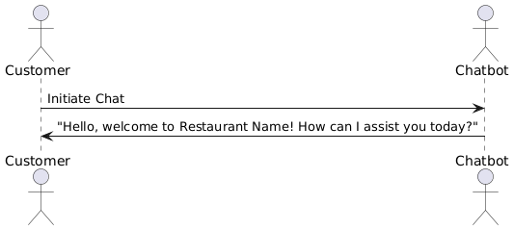

Make reservation 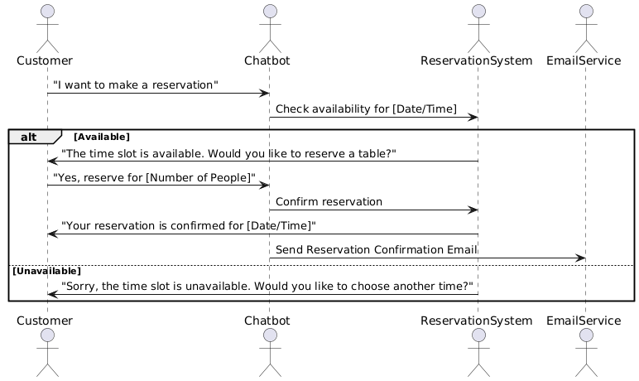Modify reservation 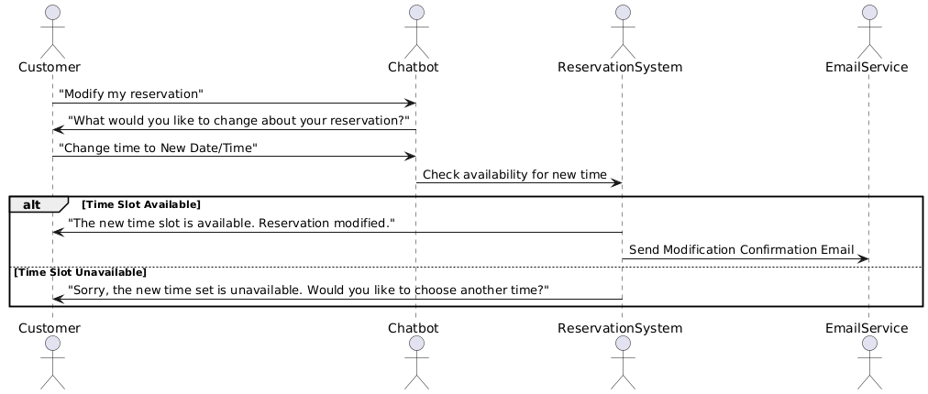Cancel reservation 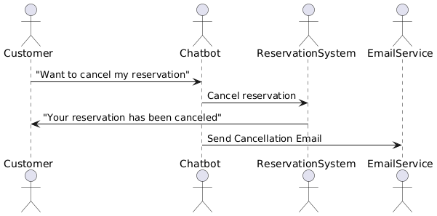

Ask about menu

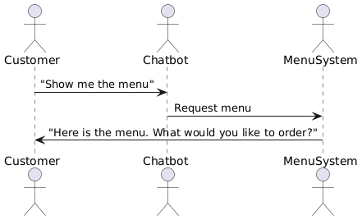

Confirm order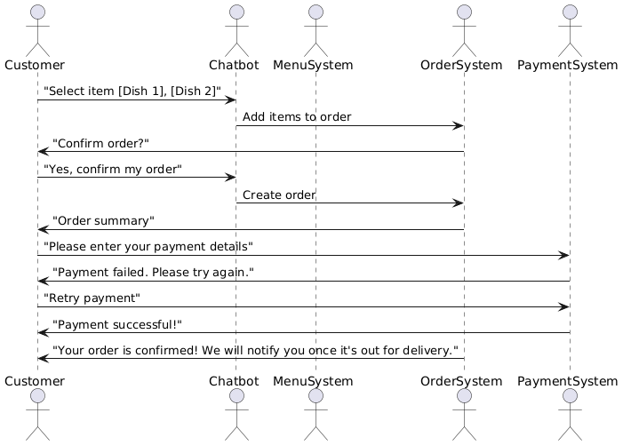Get FAQ’s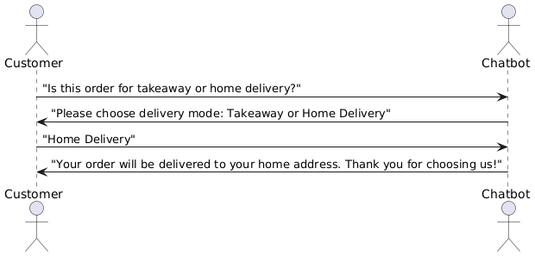

Cancel order

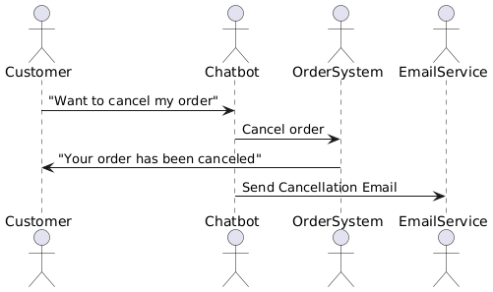

Feedback 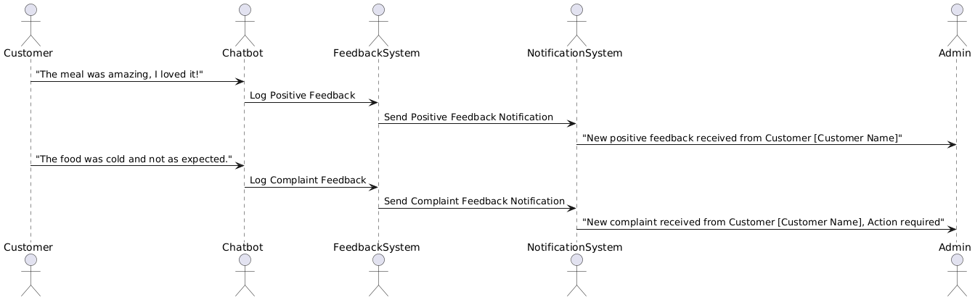Notification system 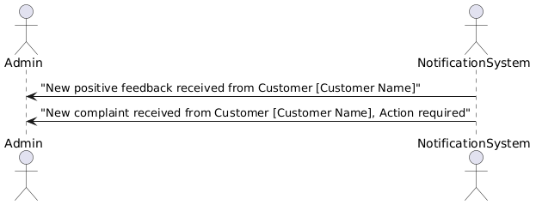

1. Architecture Design Diagram

User

Web server

Presentation layer

(HTLM, JS, CSS)

Data layer

Mysql database

Application layer

(PHP)

Data layer

My sql

Database

1. Class Diagram

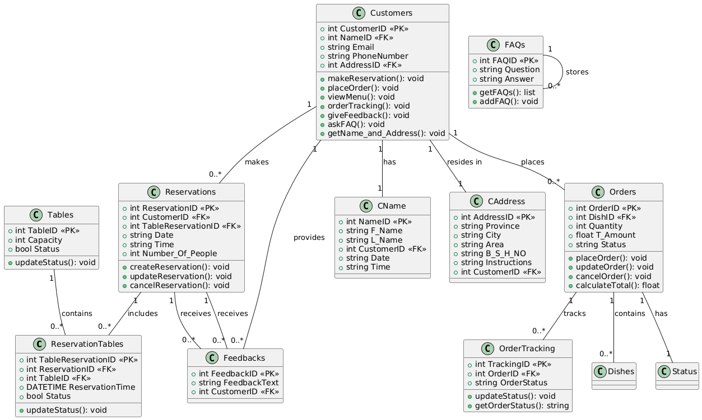

1. Database Design

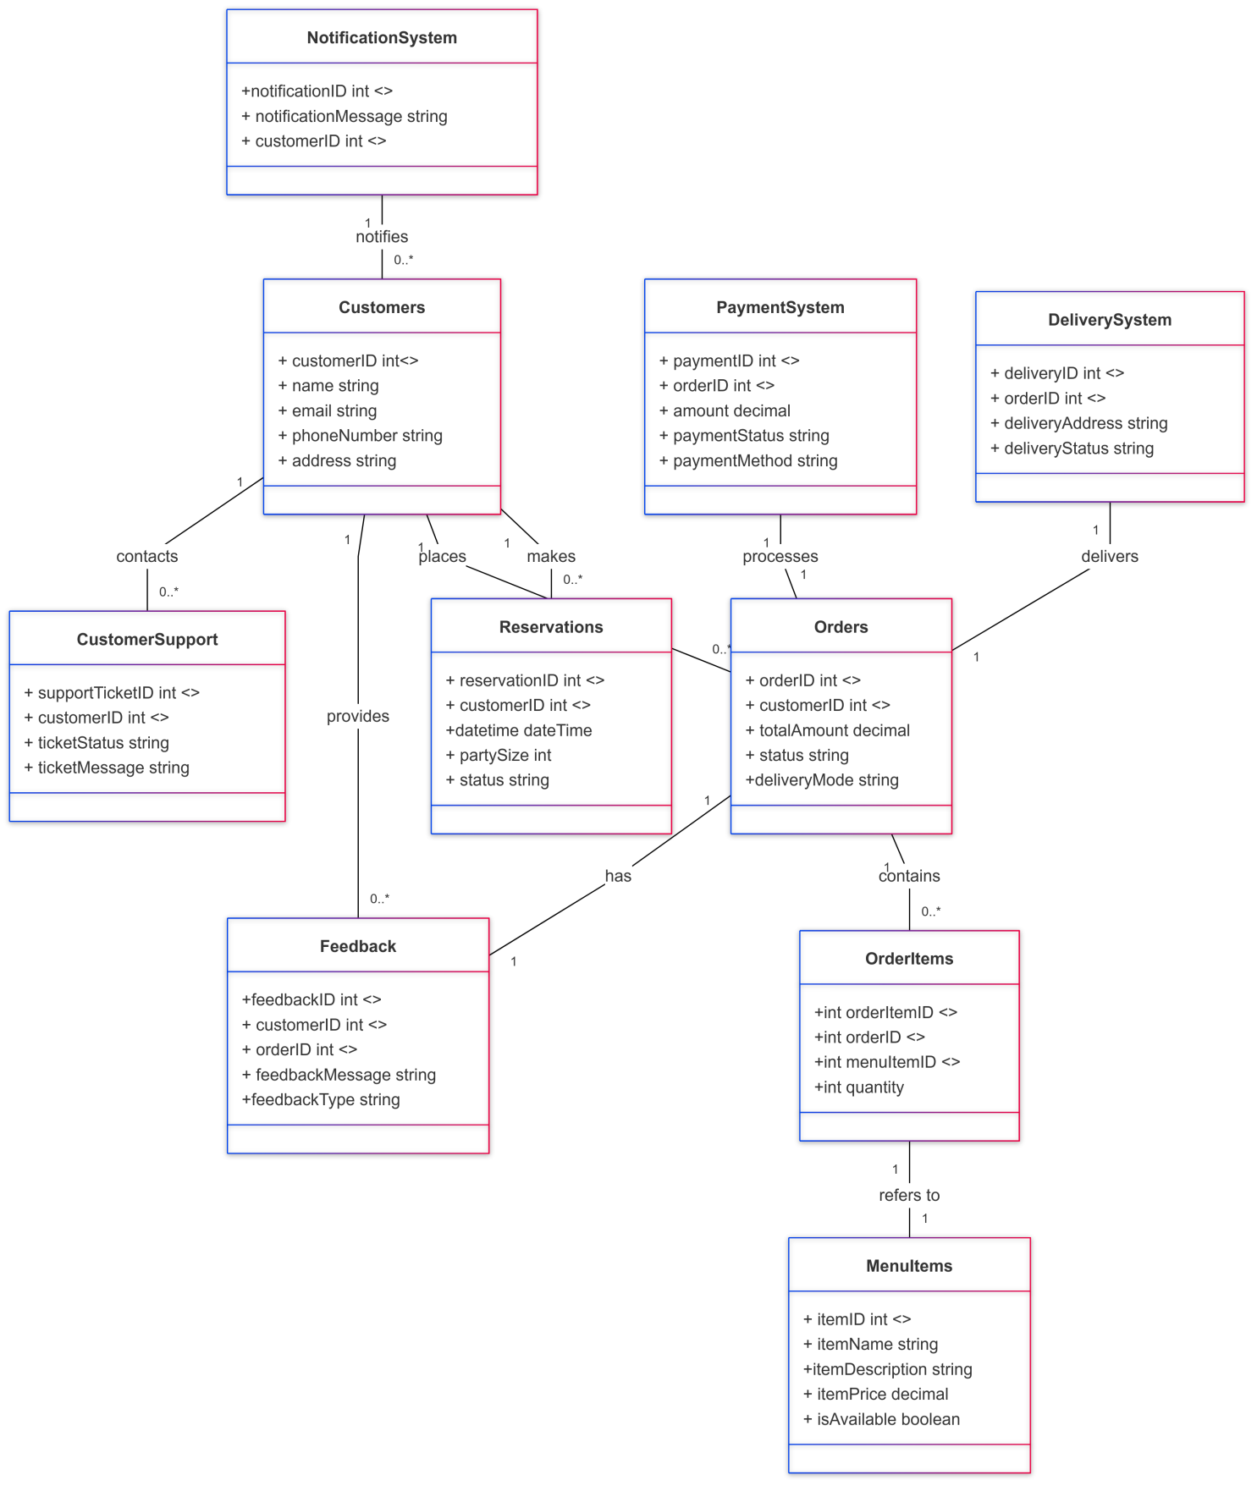

1. Interface Design

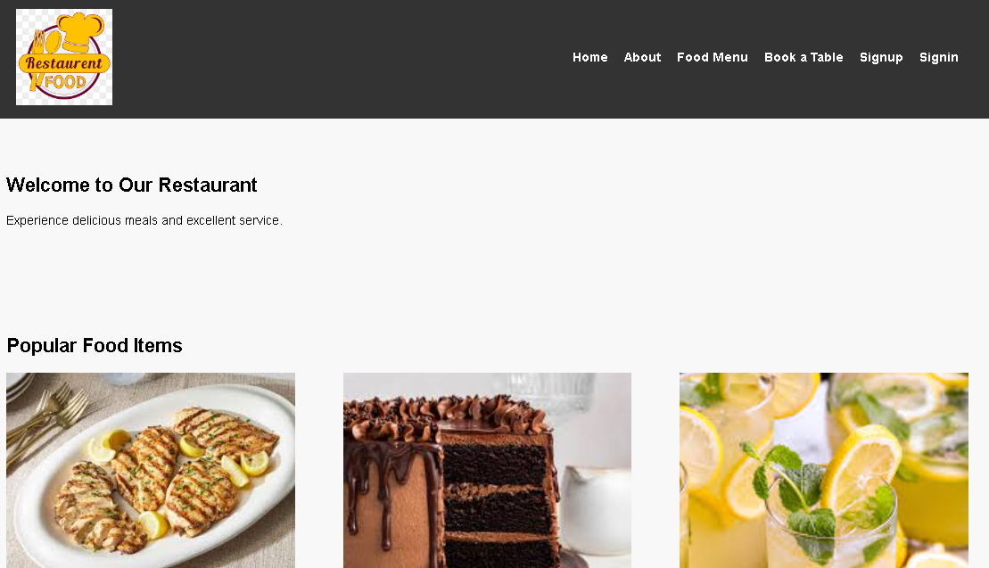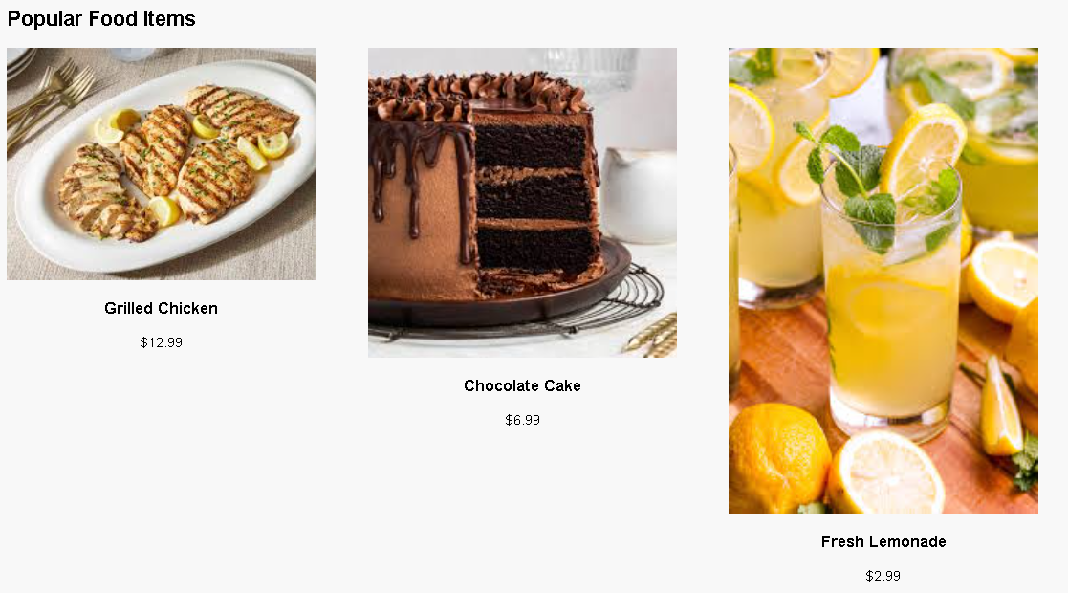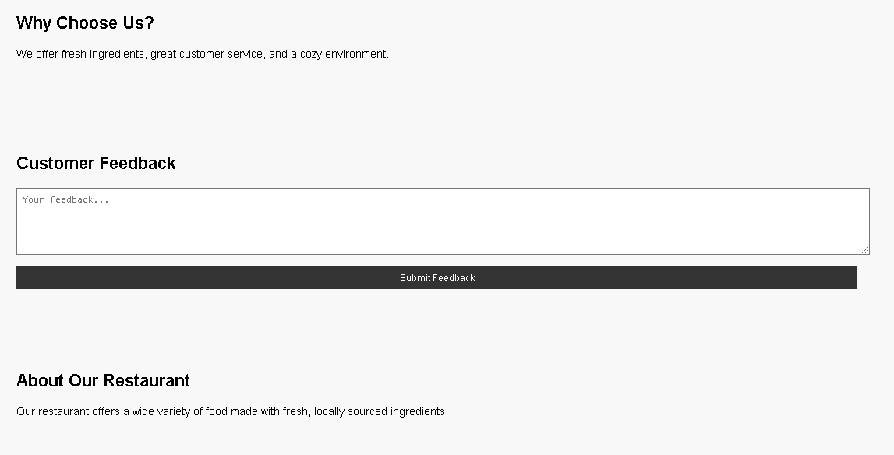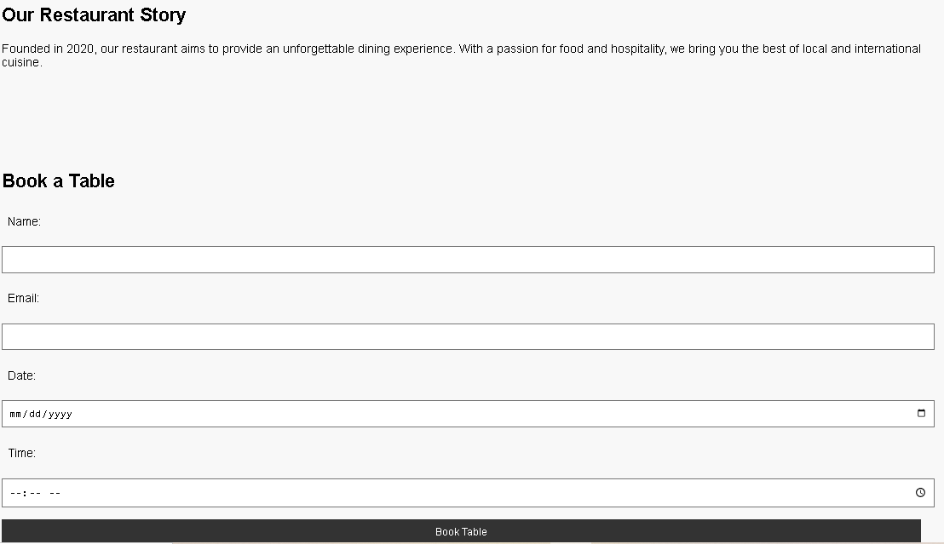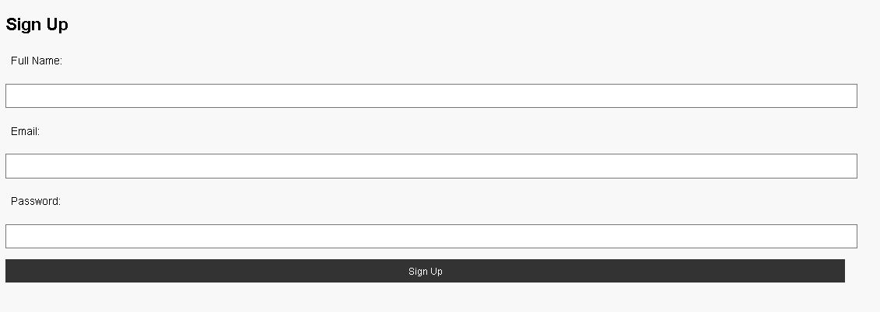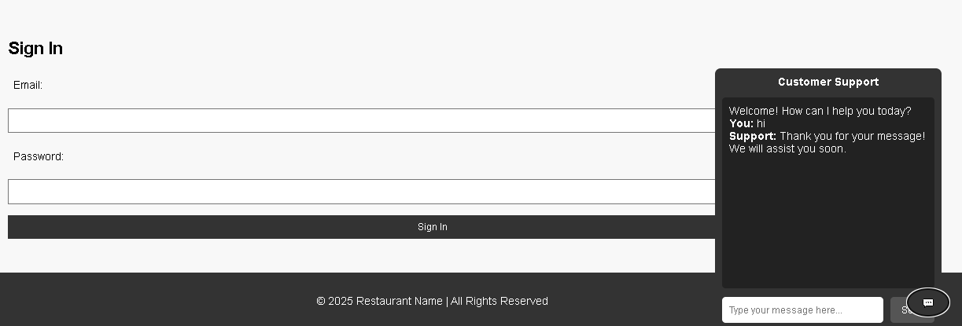

1. Test Cases

|  |  |  |  |  |  |  |  |  |  |
| --- | --- | --- | --- | --- | --- | --- | --- | --- | --- |
| **Use Case** | **Test Case ID** | **Description** | **Pre-conditions** | **Steps** | **Expected Result** | **Exceptions** | **Actual Results** | **Pass/Fail** | **Checked By** |
| Make Reservation (UC-001) | TC-001-01 | Verify customer can successfully book a table. | Customer knows reservation policy. | 1. Initiate reservation. 2. Input date and time. 3. Confirm reservation. | Reservation is confirmed. | Network issues. | Reservation confirmed successfully. | Pass | Bc230211251 |
|  | TC-001-02 | Verify alternative options are suggested if the selected time is unavailable. | Customer knows reservation policy. | 1. Initiate reservation. 2. Input an unavailable date/time. 3. Verify alternative suggestions. | Alternative options displayed. | None. | Alternative options displayed correctly. | Pass | Bc230211251 |
| Modify Reservation (UC-002) | TC-002-01 | Verify customer can modify an existing reservation. | Existing reservation must exist. | 1. Request to modify reservation. 2. Input new date/time. 3. Confirm modification. | Reservation updated. | Invalid data entered. | Reservation updated successfully. | Pass | Bc230211251 |
| Cancel Reservation (UC-003) | TC-003-01 | Verify customer can cancel an existing reservation. | Existing reservation must exist. | 1. Request to cancel reservation. 2. Confirm cancellation. | Reservation successfully canceled. | Network issues. | Reservation canceled successfully. | Pass | Bc230211251 |
| Place Order (UC-004) | TC-004-01 | Verify customer can successfully place an order. | Menu must be available. | 1. Start order. 2. Select items. 3. Confirm order. | Order successfully placed. | Invalid item selection or unavailability. | Order placed successfully. | Pass | Bc230211251 |
| Ask About Menu (UC-005) | TC-005-01 | Verify customer can retrieve menu details. | Menu must be up-to-date. | 1. Ask about menu. 2. Retrieve details. | Accurate menu information provided. | Database retrieval error. | Accurate information retrieved. | Pass | Bc230211251 |
| Get FAQs (UC-006) | TC-006-01 | Verify customer can retrieve an FAQ answer. | FAQs must be defined. | 1. Ask question. 2. Retrieve answer. | Satisfactory answer given. | FAQ database retrieval issue. | FAQ answer retrieved successfully. | Pass | Bc230211251 |
| Provide Feedback (UC-007) | TC-007-01 | Verify customer can submit feedback. | Recent dining experience required. | 1. Start feedback. 2. Input feedback. | Feedback logged successfully. | Inappropriate content or format issues. | Feedback logged successfully. | Pass | Bc230211251 |
| Receive Notifications (UC-008) | TC-008-01 | Verify customer can subscribe to alerts. | Permission granted for notifications. | 1. Subscribe to alerts. 2. Receive notifications. | User informed about updates. | Settings may fail to save. | Notifications received successfully. | Pass | Bc230211251 |